Team 2 Project 2 Stand-ups

04/27/22
Dan
Working through github planning. Making sure we have dev branches properly set up so we can manage merging.

04/28/22
Phirith
I got EF started but can't seem to get the connection string to work = blocker.
Dan
I worked further into the controllers in EF and testing them through Swagger. I worked through some blockers but have also done some slight restructuring of the models/classes in my version to achieve what I hope are better results.
Trygg
My blocker today:
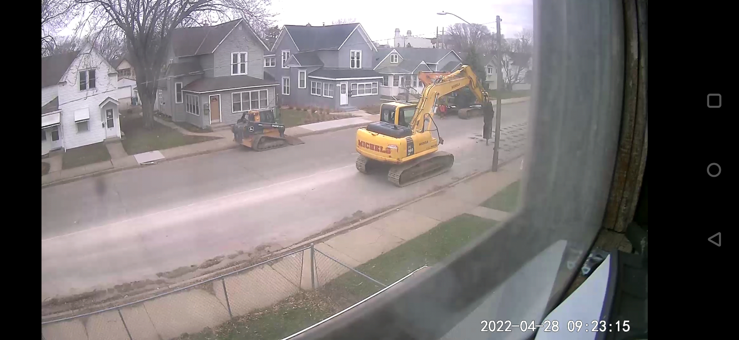(picture of road construction, right outside)

04/29/22
Phirith
Good morning team! I got some more work done on the frontend, adding buttons that's a win. My goal is to power through more tutorials this weekend and try to have to the buttons talk to the backend. Blockers = spending a lot of time researching.
Dan
Morning! I successfully managed to successfully query the api that I've been writing in C# and display that information on the web page made in angular. There's zero formatting or functions but it gets the information and displays it.
Francis
Morning, I have been working on the Angular front end. My blockers are setting everything up and understanding the file structures for angular
The backend is working well
Trygg
Progress for me is slow, but it's progress and I'm getting there. My most obvious blocker today is the construction in the street in front of my house starting at 7 AM.

05/02/22
Phirith
Morning team! Thanks to Dan I've successfully got the frontend to talk to the backend. I also put a lot of work into the design. I think it looks and functions well. Of course, there's more work to be done. My goal is to merge with everyone's work and start choosing what we want to see for our P2 presentation. Blockers = spending time to study for QC.
Dan
I've got a lot of the logic working on what will be the employee page of the website. Things like showing items, deleting them, updating them. I definitely have little bugs and quirks I'd like to iron out but overall progress seems good! Blockers are mostly CSS formatting woes
Trygg
I've been making headway on learning how to be more effective with Angular. The progress that Dan and Phirith have put forward is very impressive. My biggest blocker is being under the weather (took another covid test and it's still negative, having possible exposure has been stressing me out a bit--so maybe it's just in my head).

05/04/22
Phirith
Morning team! I got the login to the employee page to work. Still needs some work, in terms of validation and logout. But we can discuss that together to see if it's worth it for me to work on it more or focus on other tasks. Blockers = it super nice today. Don't want to be inside.
Trygg
The weather in MN yesterday and today is quite nice. I've missed the sun. I was working on configuring SonarCloud at the end of the day yesterday. When I left it, I wasn't sure if it was configured correctly yet. There seemed to be a little ambiguity in the instructions I was following and had started looking into YT videos. I'll have a better idea of what my biggest blocker is today in about an hour.
Francis
uploaded a full crud angular frontend. working on testing and making a githubactions workflow

05/05/22
Phirith
Good morning team! I got the menu page updated. Looks and functions way better. Goal today is to go over project and see needs adjustment and also fill in the missing item descriptions and about me section. Most importantly, is to practice our presentation. Blockers = nothing yet.
Dan
Morning. I figured out testing and essentially had to make a fake DB context in another class file. I made some minor changes to our returns from the controllers because I couldn't test against IActionResults, but all the functionality is still working the same as it was before. We do need to make sure we deploy our front end to Azure today
Trygg
I think we're in a pretty good spot, everything has come together nicely. If we can't get another project run-through tonight, then we can do it tomorrow morning. Or rather, we should do it tomorrow regardless, so it's fresh. My biggest blocker recently has been this Covid scare and the constraints it's putting on my day-to-day activities.

